**Software Solution**

|  |
| --- |
| American Video Game Company |
| CRM Proposal |
| Overview of Solution |

|  |
| --- |
| Richard Menz – Student ID: 001383195  7-27-2020  [Version 1.1] |

Contents

A. Introduction 3

A.1. PUrpose Statement 3

A.2. Overview of THE PROBLEM 3

A.3. Goals and Objectives 3

A.4. Prerequisites 4

A.5. Scope 4

A.6. Environment 5

B. Requirements 6

B.1. Business Requirements 6

B.2. User Requirements 6

B.3. Functional Requirements 6

B.4. NonFunctional Requirements 7

C. SOFTWARE DEVELOPMENT METHODOLOGY 8

C.1. Advantages of the waterfall method 8

C.2. disAdvantages of the waterfall method 8

C.3. Advantages of The AGILE METHOD 8

C.4. disAdvantages of The AGILE METHOD 8

C.5. best SUITED 9

D. Design 10

D.1. GUI: Contact management Dashboard and New Contact Form 10

D.2. UML Diagram: 12

E. Testing 13

E.1. Testing Type: Black Box 13

E.1.1. Test Name 1: Data Types 13

E.1.2. Test Name 2: Reporting 14

E.1.3. Test Name 3: Order management 15

# Introduction

The team has reviewed the CRM requirements document provided by American Video Game Company and feel positive our solution will deliver a product able to resolve all the business issues being faced by American Video Game Company. The need for a new Customer Relation Management System (CRM) which is a combination of practices, strategies, and technologies that are used to manage and investigate customer interaction data with the ultimate goal of keeping current customers and onboarding new clients. This improves customer relationships and assists customer retention which drives sales growth. The system we plan on implementing will improve the internal operations of American Video Game Company by providing a central application to manage current clients, reporting, tracking of sales, new client opportunities, and other critical business requirements. The CRM application we like to integrate with the American Video Game Company system in HubCentral an off the shelf product. This CRM has been used in the past with many clients and seems to be a good fit for the American Video Game Company. It should be able to integrate with the current systems seamlessly while being customizable to your special needs those solving many of the challenges a growing company would face.

# A.1. PUrpose Statement

This document exists to provide a clear and concise walk-through of everything our team will accomplish to satisfy the needs of American Video Game Company, concentrating on five specific requirements, identifying key software development practices for this project, Provider visual mock-ups of the system, and list testing requirements to verify the system will meet American Video Game Company needs.

# A.2. Overview of THE PROBLEM

American Video Game Company has grown significantly over the last two years causing them to outgrow their contact management, business data, and auxiliary system. These current systems include a collection of archaic in-house tools, spreadsheet programs, DBMS (database management systems), and many manual processes. These processes are causing too much overhead hurting productivity. The proposed system will give American Video Game Company advantageous ways to create and show reports, assign user permissions and privileges to contact delegated features of the system, and manage orders and ongoing contacts. While also being able to track sales more efficiently.

# A.3. Goals and Objectives

Once the integration is complete, the American Video Game Company should have a CRM solution that allows better management of internal business processes via a web-based solution. The listed goals and objectives will help meet these needs:

Strengthen Contact Data

Strengthen Business Data

Detailed visual reports of company actions and contact interactions

Permissions and privileges assigned by defined roles of internal and remote users

Activity management and tracking of sales

Scalable system to grow with the company with the ability to add new features

A simple, user-friendly system that is intuitive

Completely compatible with client current systems

Provide a maintenance and support structure that is accessible

A clear license model with ownership right to the relate custom development

Seemly integration with current systems to share data effectively

Security unmatched in the field

# A.4. Prerequisites

|  |  |  |  |
| --- | --- | --- | --- |
| Number | Prerequisite | Description | Completion Date |
| 1 | Broadband Internet Connection | The proposed CRM system will be available through the web. This will require a broadband internet connection with a minimum of 10 Mbps download speed. Also, an upload speed of 3 Mbps at least is needed or negative system performance may be experienced. | 08/01/2020 |
| 2 | Enhanced Database | Enhancing the database is required to make sure the new CRM system reaches its maximum effectiveness The data in the system needs to be accurate with limited redundancies to be able to generate reports promptly and smooth the operations of the contact management of the application. This also ensures the system will be able to scale in the future. | 08/15/2020 |
| 3 | Analysis and Adaptation of Existing System | Because of the many systems and different operations used by American Video Game Company, it is important to know what tools are used currently. This is done to save time and avoid extra complexities. For example, if a customer self-portal already works and can migrate into the system there shouldn’t be a need to rework that system. | 08/29/2020 |

# A.5. Scope

In Scope

* Contact Management
* Forecasting/Projections
* Opportunity management
* Management of Orders
* Management of Sales
* Report generation
* Quoting

Not in Scope

* Marketing tools and services
* Accounting tools and services
* Payroll tools and services
* Human Resources tools and services
* Training tools and services
* Development of new applications

# A.6. Environment

The infrastructure will deploy IT and hardware systems that will be simple for users to access. The user should have no trouble accessing the system and utilizing full functions if they have access to a high-speed broadband connection. HubCentral is a responsive web-application meaning it can be accessed by any device that has a reliable internet connection and a web browser. No matter the device the web-application will scale to user needs and provide full functionality. This mobility and accessibility of the web application bring a completive edge for your sales personnel that can access the CRM full functionality on the go.

# Requirements

An organization at this size with a complex client faces many different challenges that require unique and power systems. We will address five main requirements for your system which are part of business, user, function, and nonfunctional requirements. The focus on the business requirement will be contact management. For users, we will focus on finding and making special data types. To meet the functional requirements, we will address how HubCentral can make standard and/or custom reports and tools for the management of orders. Finally, to meet non-functional requirements we will focus on the security of the system.

# Business Requirements

**Contact Management:**

HubCentral provides a simple and powerful way to manage contacts. The system has intuitive ways to create, edit, and delete a contact based on role assignment in the system. Also, you will be able to filter contacts on special parameters the user depicts.

HubCentral has ways to put in partial contacts and to flag them for further information gathering and updating. The system will allow users to create contacts as a single business or a sub-contract part of an overarching business. Also, contacts will be able to be part of more then one company if they work for a multitude of companies. Any contact that is already in the system, the user will receive a notification with the ability to either override the old contactor modify the new one with multiple companies.

# User Requirements

**Data Types:**

Data types play an important part in the overall system. These data types will enable access permissions and privileges in the system. For example, the system will be able to determine based on the user signed in what updates and/or modifications they can complete. Also, the views will be different based on user roles to indicate ability per role. The system will include roles for Stakeholders, Businesses, and Contacts. HubCentral sophisticated system makes it easy to map new fields and create relationships inside the database. The database will be made in a way to be able to scale for future use and maintain a high degree of performance. HubCentral makes it easy to complete these goals and to register new users to be able to use these powerful tools.

# Functional Requirements

**Reporting:**

The CRM requires the ability to show custom defined reports and/or predefined auto-generated reports based on the house data in the database. HubCentral provides a beautify, simple, and sleek reporting dashboard capable of creating complex reports. Users will also be able to query, filer, format, and export data from these reports. These data need to be easily accessible and filtered based on the user’s role, department, or function. HubCentral comes with many powerful reports prebuild with the ability to make customized reports helping American Video Game Company bottom line.

**Order Managemen**t:

We have found that the American Video Game Company ordering platform will integrate with HubCentral with minimal tweaks to no tweaks needed. A whole host of tools will be available to ensure user track orders accurately while also proving a simple one clicks solution to take order for existing clients in the self-service customer portal. These orders will auto-generate tracking numbers for order and an ability to easily repeat previous orders. HubCentral has been customized to meet the American Video Game Company order management needs. This includes the ability to track orders, turn quotes into orders on the self-service portal, manage order tracking, and reorder previous orders.

# NonFunctional Requirements

**Security:**

HubCentral provides a built-in way to keep information secure in the system. First users will have to sign in with specific credentials to access what they should be able to access for there account. The complexity of these credentials can be defined based on the level of security needs. Also, it has a built-in way for two-factor authentications lowering the chance for someone accessing the system that should not have access. Besides that system auto reports suspicious activity and generates an email to the security team. The communication between the web-application to the DBMS is also security with top quality encryption making sure you can have the convenience and compatibility of a web-based application while not having to worry about common security flaws.

# SOFTWARE DEVELOPMENT METHODOLOGY

The waterfall method is not used often in today's market for software development like other popular methods like Agile, yet we agree that waterfall is the best method for this project. The waterfall method is one of the simple and easiest development methods to use. It sets a clear path of steps to follow and once one is complete you can go to the next much like a bucket being filled via a waterfall once it is full it starts to fill the bucket below it. The requirements have been reviewed by our team which indicates waterfall is the best solution even more so than the popular agile development method.

# Advantages of the waterfall method

The waterfall method has many advantages. The main advantage of the waterfall system is you have clearly defined expectations and unambiguity. Also, we do not see the requirements for the company to be much different then what was already shared with us. Finally, the team has worked many years gathering expertise in providing solutions such as this are confident, we can deliver and exceed expectations.

# disAdvantages of the waterfall method

Even though the waterfall method appears to be the best there are some disadvantages. The main disadvantage is it is hard to go back to a prior step once complete though this negative can be mitigated by ensuring all steps are complete fully. This rigidity is why our team takes proper precautions though the development to ensure we will not have to go back in steps because of unplanned or unforeseen changes. Another negative to the waterfall is the user will not be able to use the system until it is completed. This gives users less time to get the use of the new system navigation elements. Therefore, we focus on providing the simplest interface while proving the same power as any other CRM system.

# Advantages of The AGILE METHOD

Agile has one main strength over other methods and that is adaptability. For example, if a new critical requirement needs to be out of thin air the water method does not allow this, yet the Agile method does. The agile method also encourages frequent communication with the client to clarify requirements and make updates. The agile method defining trait is its sprints. A sprint in agile development is a short burst of development time to make specific feature followed by reflections and updates. This essentially breaks up the project into many smaller projects.

# disAdvantages of The AGILE METHOD

The main flaw of the agile system is it is hard to implement alongside an existing set of systems and tools. Implementing the agile system would cause loss of functionality until an appropriate print proves that function. The agile system is best suited for when a new system is being made for the first time. The short development and reflect periods make quick updates easy to meet customer needs. Since this project is already well defined and full functionality of the system is needed during the development of the system agile would not fit your case.

# best SUITED

The waterfall method is not perfect, but it provides the best path for success with this project. American Video Game Company has given us detailed information on the needs they have. Because of this, we have been able to organize, prioritize, and analyze the project and eliminating the need to go to prior steps and make changes. We will leverage the main strength of the waterfall using a strict step-by-step approach. This will allow us to build the application of American Video Game Company visions with the simplicity and intuitiveness they request. We have a wealth of knowledge acquired from the many years of working with other clients for years. We have used the waterfall method many times in similar situations for clients over the years leaving them satisfied with the results.

# Design

HubCentral design is a modern, simple, and sleek designed system. We have customized the dashboard to meet American Video Game Company needs. Also, all views associated with the dashboard was designed to meet the needs. One of the promising features of HubCentral is a super customizable user interface to meet anyone's specific needs. Two custom views were made to the HubCentral system to meet your needs. The focus will be on the Contact management Dashboard, which organized the data neatly and clearly. Included as well is a visual of the Add New User Form in HubCentral. Also with the design views below, we have a mock-up ERD design for a proposed database system. This database design will help to reduce redundancy and speed up database operations to ensure HubCentral operates at a peak effect.

# GUI: Contact management Dashboard and New Contact Form

Below is the Contact Management Dashboard created by our team to meet the American Video Game Company's unique business needs. The information on the left displays shows basic contact information. The center section displays much important information about the client including recent activities such as phone calls, emails. notes on file, and tasks that are assigned. The right area gives the ability to modify, filter, and add new contacts. On the right side, it also includes a Preferences option to be able to modify Marking Preferences as well as Contact Preferences.

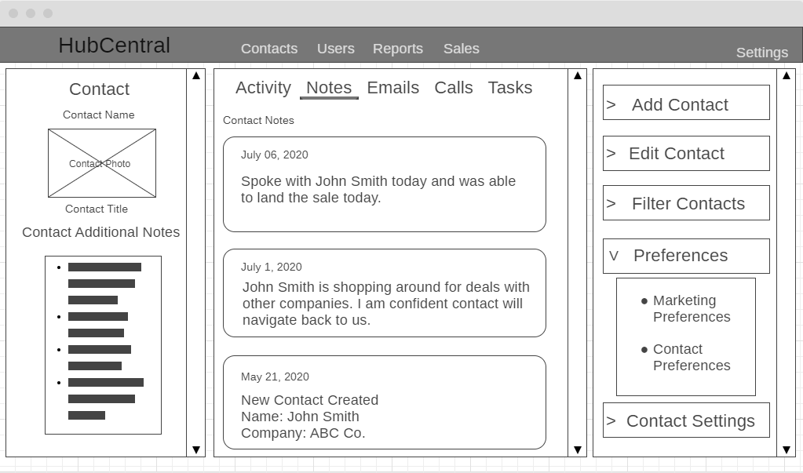

Figure 1: HubCentral Contact Management Dashboard GUI Mock-up

Below is HubCentral’s Create New Contact form. The list of required fields is depicted via red asterisk. Many fields can be added or removed to meet the contact's specific needs. This allows contact to be part of more than one company and house special notes from the specific client. To access this form, it is as easy as selecting the Add Contact section from the previous Mock-Up for Contact Management Dashboard.

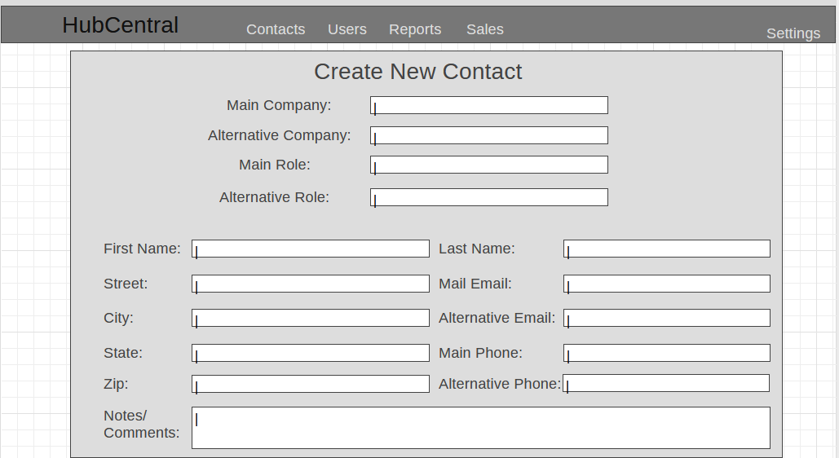

Figure : HubCentral New Contact Form GUI Mock-up

# UML Diagram:

Below is an ERD (entity relationship diagram) from a proposed setup for the database to ensure HubCentral speedy operations. The entities(tables) are not exactly what would go into production. We would need more information from the American Video Game Company to assist in updating the database design. Also, the entity user listed below "User" is a placeholder for integration with your activity directory and data pulled from such for the database operations. In the diagram below all primary keys are listed in bold and all foreign keys are listed in italics. Many tables were broken down into sub tables to reduce the redundancy of data and increase the operation speed of that proposed database.

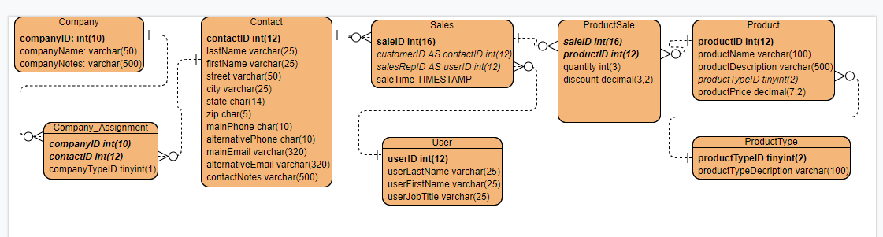

Figure 2: HubCentral New Contact Form GUI Mock-up

# Testing

Three main requirements will be tested throughout the project for the American Video Game Company. The first test will be composed of verifying contacts that have the proper roles assigned and filtered properly for business needs. The second test will include a test for reporting features to verify proper integration into the existing system and property reports on the provided data. Lastly, a test will be conducted to ensure the functionality of the Order Management feature.

# Testing Type: Black Box

The team has decided the best testing choice would be the black box method. Because this solution is based on a commercial off-the-shelf product, most of the features to be implemented have already been completed by their development team. This is why our goal is to ensure proper configuration and customization of the product to meet the American Video Game Company business needs and operations.

# Test Name 1: Data Types

|  |
| --- |
| The requirement to be tested:  This test will check whether contact roles are being represented accurately by the proper data type in the system. An example would be if contact was made with the role of Sales Personnel and a user wants to send out a task to be completed in the system for Sales Personnel only. Then, the system should only allow people in the sales personnel group to be able to view this task. |
| Preconditions:  The contact(s) must be in the system and must have a proper role(data type). |
| Steps: The steps the tester must execute to test the feature.   1. Login into the system by using personal credentials 2. Navigate to the Contact Management page 3. On the right side of the page select Filter Contacts 4. Via the group down menu, select “Filter Contacts by Role” 5. Select the business from which the contact is part of 6. Select the role you want to view in this instance it would be “Sales Personnel” 7. Click the “assign a Task” button 8. Next, generate the task you want to perform by typing. 9. Once done typing hit the “Send Task” button |
| Expected results  As long as the system is working properly only the personnel with the role sales personnel from the selected company will receive the task which you have assigned to them. Negative results can be caused by a wrong role being selected for the contact which would cause them to receive information not intended for them. This is why our team rigorously validates the data to make sure all data in the system is correct. |
| Pass/Fail:  PASS: in the testing multiple tries at causing a break in the system, information is being provided to the correct roles. This part of the system is ready to be placed in the production environment. |

# Test Name 2: Reporting

|  |
| --- |
| The requirement to be tested  American Video Game Company requires the system to provide custom reports and standard pre-built reports. Also, the user interface needs to include a way to export, filter, query, and format the data. |
| Preconditions:  To be able to meet this goal the database needs to be optimized to meet the speed and data efficiency to realize maximum performance of HubCentral. American Video Game Company needs to have a query with extreme accuracy that utilizes optimization techniques to meet the proper system disk space allocation. |
| Steps: Two sets of steps will be completed on whether you are doing normal or customer reports  Custom Reports:   1. Login into the system by using personal credentials 2. Navigate to the Reports page 3. Click on “Filter Custom Report” 4. Click on “Annual Net Profits” 5. Click on “Filter By” and select “Mobile Sales Only” 6. Select “Run Report” 7. Click on “View Visual report” 8. Build and run the same query with the same database 9. Verify the numbers match between the report and query.   Standard reports:   1. Login into the system by using personal credentials 2. Navigate to the Reports page 3. Click on “Report: Gross Sales-Monthly” 4. Select date with an onscreen calendar with the date range of “August 1, 2020, through August 31, 2020” 5. Select “Run Report” 6. Click on “View Visual report” 7. Build and run the same query with the same database 8. Verify the numbers match between the report and query. |
| Expected results:  As long as the database holds correct and non-redundant data, these report features should run the numbers and display them in visual reports that can then be fully customized into many types of visual aids including a bar graph, PERT, and pie charts. |
| Pass/Fail:  PASS: In the testing both custom and stand reports pass. Attempting multiple reports or each type the results displays accurate information in visual charts and graphics. This feature is production-ready and can go to the live system immediately. |

# Test Name 3: Order management

|  |
| --- |
| The requirement to be tested  The management of orders is one of the most important parts of the system. Testing should be the focus on this aspect of the system which is why it will be tested last. American Video Game Company already has a customer portal to purchase from. This new system will need to integrate with this system and allow more robust order management. |
| Preconditions:  American Video Game Company's existing customer portal needs to be tightly integrated into the new HubCentral system before testing can start. |
| Steps: The steps the tester must execute to test the feature.   1. Log into the sales portal with personal credentials 2. Place an order for a computer game 3. Confirm Order details and process order 4. Logout of the sales portal 5. Login to HubCentral 6. Navigate to Order management tab 7. Under recent orders verify this order shows in the system. |
| Expected results:  Any sales made in the customer portal should show in the HubCentral system. |
| Pass/Fail:  PASS: After making many test orders, each order came from the portal always showed up in HubCentral. This feature is ready for the production environment. |